SQL
Session-8
1.Write a PL/SQL block that declares two variables: one for a user's name (VARCHAR2) and one for their age (NUMBER). Assign values and print both using DBMS_OUTPUT.PUT_LINE.
DECLARE
name varchar2(20):='Neha Pal';
age int := '20';
BEGIN
dbms_output.put_line(name);
dbms_output.put_line(age);

END;
/
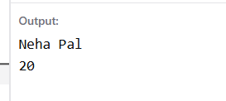

2.Create a PL/SQL block that uses an IF statement to check if a given order amount is above 500. If yes, print 'Eligible for free delivery', else print 'Delivery charges apply'.
DECLARE
amount float:=2500;
BEGIN
if amount > 500 then
dbms_output.put_line('Eligible');
else
dbms_output.put_line('Not Eligible');
end if;

END;
/
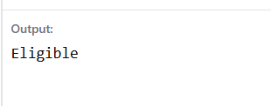

3.Write a PL/SQL block that uses a simple LOOP to print the numbers 1 to 5 using DBMS_OUTPUT.PUT_LINE. Use a counter variable and EXIT WHEN condition inside the loop.
SET SERVEROUTPUT ON;

DECLARE
counter NUMBER := 1;
BEGIN
LOOP
DBMS_OUTPUT.PUT_LINE(counter);
counter := counter + 1;

EXIT WHEN counter > 5;
END LOOP;
END;
/
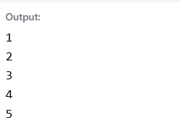
4.Declare a cursor in PL/SQL to select all product names from a table called PRODUCTS. Fetch each product name and print it using DBMS_OUTPUT.PUT_LINE. Assume the PRODUCTS table has a column PRODUCT_NAME.
DELIMITER //
CREATE PROCEDURE getnameByRow()
BEGIN
DECLARE v_id INT;
DECLARE v_name VARCHAR(100);
DECLARE done INT DEFAULT 0;
DECLARE restaurantsCursor CURSOR FOR
SELECT id, name FROM restaurants;

DECLARE CONTINUE HANDLER FOR NOT FOUND
SET done = 1;

OPEN restaurantsCursor;

ploop: LOOP
FETCH restaurantsCursor INTO v_id, v_name;

IF done = 1 THEN
LEAVE ploop;
END IF;

SELECT v_id, v_name;

END LOOP ploop;

CLOSE restaurantsCursor;
END //
DELIMITER ;

CALL getnameByRow();
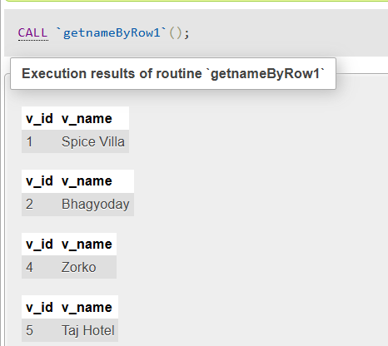

5.Write a PL/SQL block that tries to divide two numbers entered as variables. If a division by zero occurs, catch the exception and print 'Cannot divide by zero'. Otherwise, print the result.
SET SERVEROUTPUT ON;

DECLARE
num1 NUMBER := 10;
num2 NUMBER := 0;
result NUMBER;
BEGIN
result := num1 / num2;
DBMS_OUTPUT.PUT_LINE('Result = ' || result);

EXCEPTION
WHEN ZERO_DIVIDE THEN
DBMS_OUTPUT.PUT_LINE('Cannot divide by zero');
END;
/
